Steps by Step:
- Acces transaction BP.

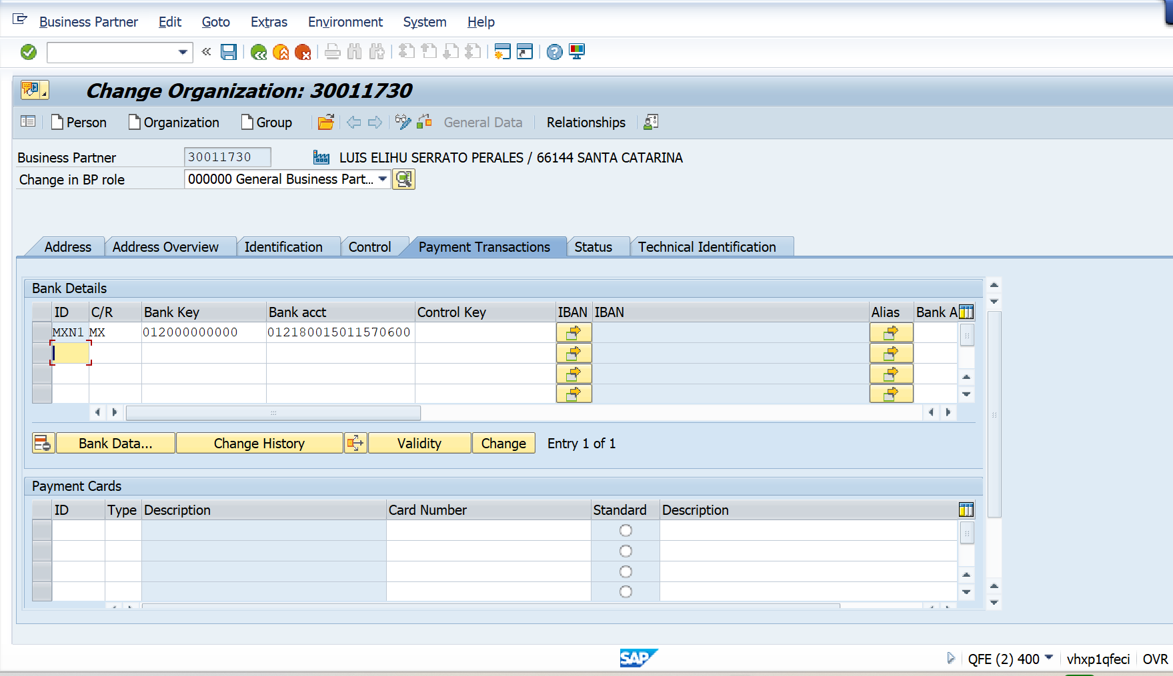

- Add Account Bank:

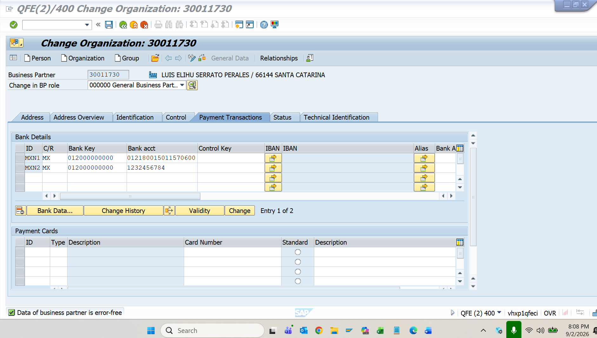

- Save it:

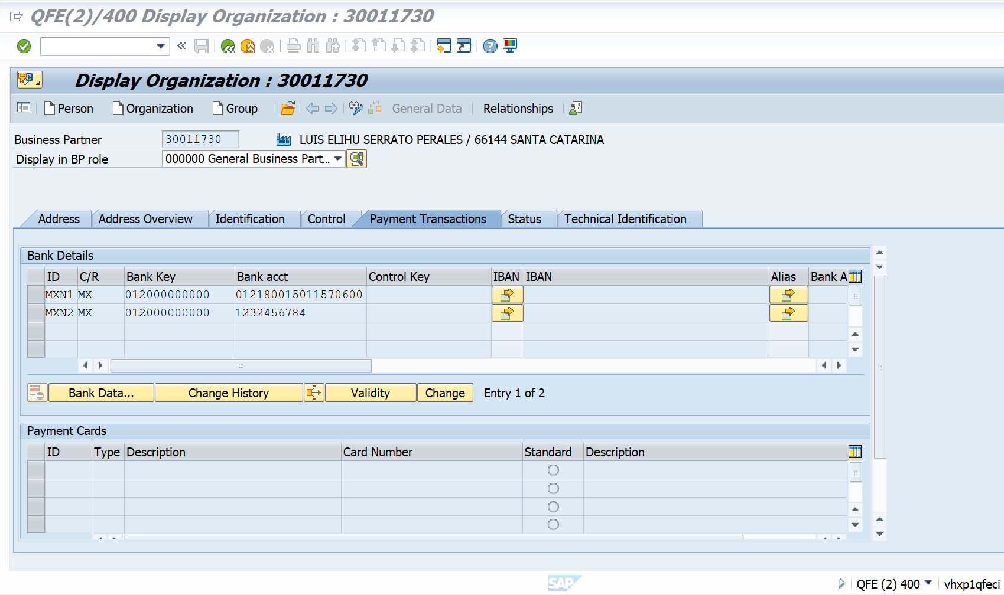

Go to Tables:

In table BUT0BK there are two accounts:

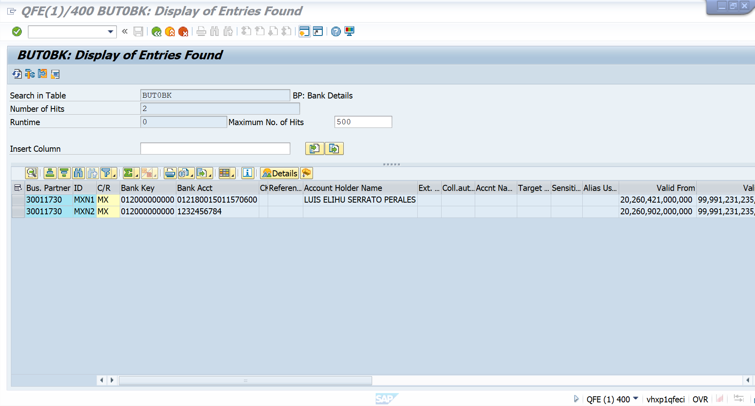

In table:
LFBK there is only one bank account

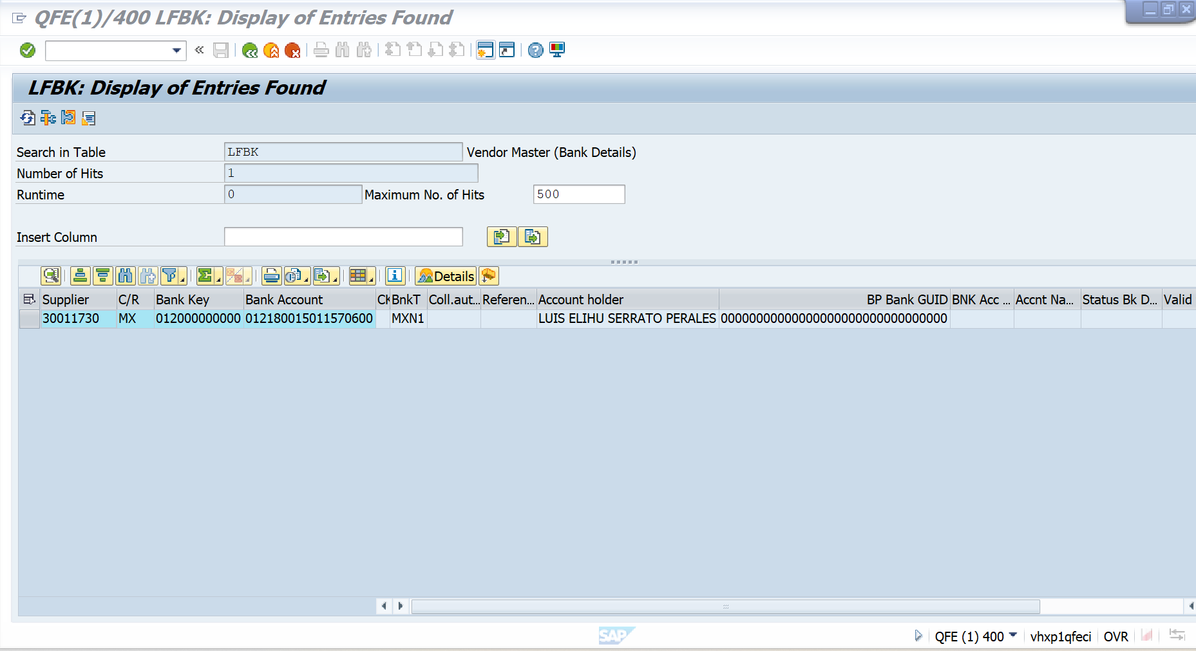

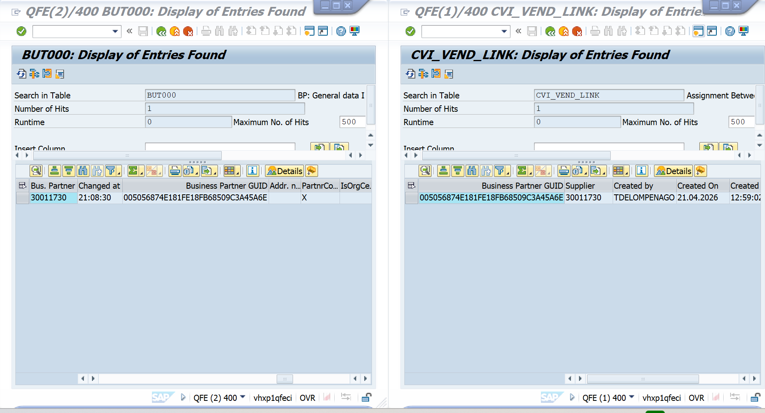

Note: Additionally, we are unable to view the bank details in MIRO because the related bank tables are not synchronized. As a result, the bank information is not being displayed correctly during invoice processing.

